vsMSSGateway Troubleshooting Guide

Note – Jump to Appendix C for Summary, Environment, and Transaction Flow diagrams.

Overview:
The vsMSSGatewayDB service is a communication application designed to act as a gateway between numerous internal DOL applications and the Message Switching System (MSS) interface of the WSP ACCESS switch. Internal DOL applications share a common outgoing queue for each instance of the vsMSSGatewayDB, but each application has its own incoming message queue(s).

Incoming Messages:
The MSS Gateway maintains a SQL table (in the vsMSSGateway database) to associate incoming message identifiers with a particular incoming queue. Upon start up, the MSS Gateway application will query this table to determine which incoming queue will be used for each message received. When an incoming message arrives from the MSS, the MSS Gateway will look at the message header and compare the message identifier with its list of known message identifiers to determine into which queue the message needs to be written. If the message identifier matches a known identifier, it will write the message to the appropriate queue. If the message identifier does not match a known identifier, it will log an event and write the message to a common, unknown messages table in the MSS SQL database.

Each application monitors it's incoming queue for new messages. When the MSS Gateway writes a message to an application’s queue, it is up to the application to monitor the queue or accept notifications in order to process it’s queue.

Outgoing Messages:
Whenever an application needs to transmit a message to the WSP MSS, it writes the message to the common outgoing queue (DBQTx). When a message arrives in the outgoing queue, the MSS Gateway application will process the outgoing queue and transmit the message(s) to the ACCESS switch.

vsQueueWrapper.DLL:
A wrapper DLL was created to encapsulate the common MSMQ COM objects used by the MSS Gateway and individual DOL applications. The vsMSSGateway application and the internal DOL applications utilize this DLL to facilitate development and to insure all queue messages are formatted correctly for the queues.

General Operation:
Upon start up, the vsMSSGateway application reads its registry settings at HKEY_LOCAL_MACHINE\SYSTEM\CurrentControlSet\Services\vsMSSGateway. Registry settings contain both the remote server information (IP, port, etc.) and the application’s database connection string. After obtaining the database connection string information, the application connects to the vsMSSGateway database as user “vsMSSGatewayUser” and reads the remaining start up parameters and list of queues to manage.

When the database values have been read, the gateway attempts to open all of the queues that it needs to operate. Next, the application attempts to connect to the remote server. Upon connection, vsMSSGateway begins its primary function of passing messages between the ACCESS switch and the DOL application queues. Any errors that the system encounters are logged to the NT Application Event Log.

Detailed Operation:
When the MSSGateway has a message to send to the ACCESS switch, it reads the message from the queue and sends the message to the ACCESS switch. The MSSGateway holds the message in memory until the ACCESS switch ACKs the message. If the ACCESS switch does not ACK the message, the MSSGateway will return the message to the queue and report the problem. When the ACCESS switch ACKs the message, the MSSGateway either repeats the process for the next message in the output queue OR responds to any incoming messages from the ACCESS switch.

When the ACCESS switch sends a message or response to the MSSGateway, the MSSGateway accumulates all of the data until it finds the ETX character (the TCP/IP protocol can break the data into multiple packets so there is no guarantee that an entire message/response will come in as a complete unit so the MSSGateway buffers received data until the ETX character is received). Once the MSSGateway has a complete record, it attempts to locate the appropriate individual process queue to write the message. If the message is successfully written to the queue, the MSSGateway ACKs the ACCESS switch. If the message cannot be written to a queue (unknown message, queue not open, etc.) the message is written to the tblUnknownMessages table. Once the message has been written to the tblUnknownMessages table, the MSS Gateway will ACK the ACCESS switch.

If an incoming message cannot be written to either a queue or the tblUnknownMessages table, the MSS Gateway does NOT ACK the ACCESS switch and sends an e-mail error message. Such messages remained queued in the ACCESS switches queues.

IMPORTANT NOTE: If either of the ACCESS switch queues (NCIC or WACIC) build up too many messages, responses from that queue will be delayed or may not be sent to the MSSGateway at all. If this happens, clearing the queue(s) in question and resetting the line will likely help. See Miscellaneous errors below for instructions.

Errors
Every error condition will generate a message in the NT Application Event Log. In addition to the NT Event log, e-mail notification will occur in the following cases:

E-Mail Notifications
E-mail Message | Cause/Solution
“Insufficient parameters to proceed (ctlNTService1.Start).” | This error will occur upon start up if the application is unable to obtain the necessary minimal parameters to proceed. The following values are all required:  Registry Settings:  HKEY_LOCAL_MACHINE\SYSTEM\CurrentControlSet\Services  \vsMSSGateway\Parameters  Local Server – IP address of the local socket.  Remote Server – IP address of the ACCESS switch  Remote Port – server port of the ACCESS switch  Mnemonic – WSP assigned terminal mnemonic for the ACCESS switch  Tx Queue – common output queue used by this instance of the application. If blank, the application will use the QTx value in the database described below)  DB Settings (vsMSSGateway.tblMSSConfig):  ConnectTimeout – must be greater than zero; typical value is 30  HeartbeatInterval – must be greater than one; should be 60.  LogSentMessages – normally this should be zero. Set to 1 to log sent messages to the event log for debugging purposes.  ConnectTimeout – must be greater than zero; typical value is 30  QRxTimeout – must be greater than zero; typical value is 100  QServername – must not be blank; should contain the name of the server that the queues reside on, including the \PRIVATE$\ keyword if private queues are used. E.g. – DOLUTOLYQSVR\PRIVATE$\  QueueRetryCount – must be greater than zero; typical value is 5.  QueueRetryInterval – must be greater than zero; typical value is 30  QTx – Should include the name of the output queue; typical value is “QTx”. This database value is used when the “Tx Queue” registry setting described above is NOT specified.  RetryInterval – must be greater than zero; typical value is 60.  ConnectTimeout – must be greater than zero; typical value is 30  Other:  tblQueueList – must not be empty.
“One or more queues failed to open. See the Application event log for details (ctlNTService1.Start).” | This error will occur upon start up if the application is unable to open one or more queues in the queue list. See the event log for details on which queue(s) did not open.
E-Mail or Log Event message:  “Unable to establish socket connection. Tried n times." | This error will occur if the application is unable to establish a connection after repeated attempts. The number of attempts is determined by the RetryCount parameter in the tblMSSConfig table of the vsMSSGateway database.  Check the event log for additional error messages or winsock errors for further indication for the cause of the failure. See the “Winsock Errors” table below for winsock error meanings.
“Received MSS Message had an unknown header (ctlSocket1.Receive)." | This error indicates that an unknown message was received by the ACCESS switch. Although this error should not occur, if it does, the e-mail will also contain the raw message received for analysis.
“The following message was not ACK'ed (ctlSocket1.Receive).” | This error will occur in the event that a message was received from the ACCESS switch but the message was neither written to the queue nor saved to the tblUnknownMessages table. This normally would not occur unless an unknown message was received and was unable to be saved to the database due to a network or server problem. Such errors should be immediately investigated.
"Message written to unknown table. Message details: " | This error will appear whenever the application writes a message to the tblUnknownMessages table of vsMSSGateway. This will occur when the application cannot determine into which queue the message belongs or if the message was unable to be written to a particular queue, such as if a queue was deleted after the application was started or if a queue was disabled.  The error will also contain the raw message received.
“Failed to re-open queues (attempt X). Will try Y times.” | This error will occur when the queues have been closed but could not be re-opened. See the following e-mail error message for further details.
“Unable to re-open queues. Tried n times. Service is stopping.” | The application will attempt to re-establish a connection to the underlying queues in the event the connection is lost. If it fails after QueueRetryTimes (waiting QueueRetryInterval seconds between attempts), this message is sent and the service is stopped. Any queue messages will remain in their queues or remain queued in the ACCESS switch’s internal queues.  Examples of a lost queue connection could be if the vsMSSGateway and queues reside on different machines and the queue server is shutdown/rebooted or if queues are manually deleted without notifying the vsMSSGateway via it’s tblMSSConfig and/or tblQueueList table.

Winsock (Windows Socket) Errors:
Below are common Winsock errors and possible solutions. Certain errors are not user-fixable. In those cases, the Possible Solution field is left blank. In cases where a Possible Solution is provided, the solution applies generally to winsock applications. Explicit reference to the vsMSSGateway is provided when appropriate.

Note: A Socket is a communication point that allows an application on a computer to communicate with a remote computer via the remote computer’s socket(s). A socket is the combination of the computer’s IP address, a port number (a numeric value between zero and 65536) and protocol (TCP or UDP). Winsock is the WINdows SOCKet API which provides the interface for sockets in the Windows environment.

Error Code | Description | Possible Solution
10004 | System level interrupt interrupted socket operation.  A blocking operation was interrupted by a call to WSACancelBlockingCall internal to Winsock.DLL.
10009 | Generic error for invalid format, bad format.  A BSD socket is equivalent to a file handle. Some Windows Sockets platforms provide some file handle and socket equivalency. In this case, the WSAEBADF error might mean the same as a WSAENOTSOCK error.
10013 | Generic error for access violation.
10014 | Generic error for fault.  WinSock spec notes that this error occurs if the length of the buffer is too small.
10022 | Generic error for invalid format, entry, etc.

10024 | Generic error for file error. | This error should not occur. The error means the network system has run out of socket handles.  It may indicate that there are too many WinSock applications running simultaneously, but this is unlikely since most network systems have many socket handles available.  It could also occur if an errant application opens and closes sockets often, but doesn't properly close the sockets (so it leaves them open, as "orphans"). To recover the orphaned sockets, you can try closing the errant application and restarting it to recover the open sockets; you may have to end all WinSock applications (to force an unload of the WinSock DLL).
10025 | The IP address provided is not valid or the host specified by the IP does not exist. | Verify the Remote Server registry setting for the vsMSSGateway service is correct and valid.

10035 | The specified call would block a non-blocking socket.  The socket is marked as non-blocking (non-blocking operation mode), and the requested operation is not complete at this time. | This error should not occur or if it does, it should be detected and ignored. 10035 errors can be safely ignored.  If error 10035 occurs and interrupts vsMSSGateway operation then a coding change needs to occur in the procedure throwing the error. The coding change needs to detect and ignore the error.
10038 | Invalid socket or not connected to remote.  An operation was attempted on an invalid socket handle (either it never was valid, it's a file handle (not a socket handle), or if it was a socket handle, it has been closed). | This error should not occur. If error 10038 occurs and interrupts vsMSSGateway operation then a coding change needs to occur in the procedure throwing the error. The coding change verify the socket is valid before attempting to perform an operation on the socket.
10048 | The specified address is already in use.  This error occurs when an application attempts to open a socket that is already opened by another process.  Example: If an attempt is made to run two instances of an application that specify an explicit socket, this error would occur when the second application attempts to run (such as attempting to start two FTP servers on the same machine and both attempt to listen on port 21). | Client applications should not specify explicit sockets.  Since the vsMSSGateway is a client socket application, this error should not occur.  When the vsMSSGateway creates its socket, it uses the IP 0.0.0.0 and port 0 which instructs winsock to pick an available socket on the local machine.

10049 | The specified address is not available.  Occurs when an attempt is made to create a socket that is not available on the machine. | This error should not occur because the vsMSSGateway creates its socket by specifying an IP of 0.0.0.0 which instructs winsock to pick an available socket.
10050 | The connected network is not available.  When it occurs, it could indicate a serious failure of your network system (i.e. the protocol stack that the WinSock DLL runs over). | Check your WinSock, protocol stack, network driver and network interface card configuration.  Note that this error occurs rarely since a WinSock implementation cannot reliably detect hardware problems.
10051 | The connected network is not reachable.  The local network system could generate this error if there isn't a default route configured. Typically, WinSock generates this error when it receives a "host unreachable" ICMP message from a router.  The ICMP message means that a router can't forward the IP datagram, possibly because it didn't get a response to the ARP request (which might mean the destination host is down). | This error generally occurs when a router is misconfigured. A tracert could be attempted to determine where the failure occurs.
10052 | The connected network connection has been reset.  The destination host was likely re-started. | Same as 10053.

10053 | The current connection has been aborted by the network or intermediate services.  The error can occur when the local network system aborts a connection. This would occur if WinSock aborts an established connection after data retransmission fails (receiver never acknowledges data sent on a datastream socket) or winsock caused a connection abort because there is no space on the socket's queue and the socket cannot receive further connections.  TCP/IP scenario: A connection will timeout if the local system doesn't receive an ACK for data sent. It would also timeout if a FIN TCP packet is not ACK'd (and even if the FIN is ACK'd, it will eventually timeout if a FIN is not returned).  IMPOTANT NOTE: The ACK mentioned above refers to the TCP/IP stacks internal acknowledgement of valid data, NOT the session layers ACK specified in the MSS External Interface Programmer's Guide. | A network failure occurred. The vsMSSGateway will automatically attempt to recover from 10053 errors by attempting to re-establish the connection.  If the problem was transient, a subsequent connection attempt should be successful.  If a connection is not successful, a different error should be reported because the 10053 only occurs after a valid connection was established. Refer to the new error for additional information.  If the connection aborts frequently because of 10053 errors, diagnostic testing of the network should be performed to determine the cause of the failures (bad cables, faulty/flakey network equipment, etc.).
10054 | The current socket connection has been reset.  A connection was forcibly closed by a peer. This normally results from a loss of the connection on the remote socket due to a timeout or a reboot.  This reset could also be generated locally by the network if it detects a connection failure, or it might be received from the remote host if the remote host sent a RST (reset) packet. | Same as 10054.

10055 | No buffer space available.  An operation on a socket or pipe was not performed because the system lacked sufficient buffer space or because a queue was full. The WinSock implementation was unable to allocate additional memory to accommodate the function request. | This error indicates a shortage of resources on the server.  It can occur if there are too many applications (of any kind) simultaneously on the machine.  If this tends to occur after running certain applications for a while, it might be a symptom of an application that doesn't return system resources (like memory) properly or certan applications are not closing properly.  If it persists, exit Windows or reboot your machine to remedy the problem. Monitor system resources if the problem frequently occurs.
10057 | The current socket has not been connected.  A request to send or receive data was disallowed because the socket is not connected. An application attempted an input/output network function call before establishing an association with a remote socket. | Same as 10038.
10058 | The connection has been shutdown.  A request to send data was disallowed because the socket had already been shut down. | Similar to 10038. The vsMSSGateway should not attempt to send any data on a closed socket.

10060 | No connection could be made because the target machine actively refused it. | Same as 10061.  Verify the vsMSSgateway destination IP and port are correct.  Verify the IP address of the computer running the vsMSSgateway service is in the WSP router’s ACL (firewall).
10061 | The requested connection has been refused by the remote host.  This usually results from trying to connect to a service that is inactive on the destination host or if the connection request is not making it to the destination host due to a firewall setting. | Either the application attempted to connect to the wrong server or the server rejected the connection attempt for security reasons.  Verify the Remote Server and Remote Port registry settings for the vsMSSGateway service are correct.  Verify the Mnemonic value specified is a valid value from the WSP.  Verify the machine you are attempting to connect from was set up in the WSP’s firewall.  If the Regional connection is down (mnemonic DOL10) Call the WSP Data Center at 705-5778 to confirm that the ACCESS service is functioning. Ask them to bring up line WSPHQ 80.  If the DB connection is down, call the same number but ask them to bring up WSPHQ47.
10063 | Specified host name is too long.
10064 | Remote host is currently unavailable.
10065 | Remote host is currently unreachable. | Same as 10051.

10091 | Remote system is not ready.  The WinSock implementation cannot function at this time, because the underlying system it uses to provide network services is currently unavailable. | Check that the WINSOCK.DLL file is in the current path.  Check that the WINSOCK.DLL file is from the same vendor as the underlying protocol stack (the WINSOCK DLLs must be supplied by the same vendor that provided the underlying protocol stack).  Verify there is only one instance of Winsock. It is not permitted to use more than one WinSock implementation simultaneously. If there are multiple WINSOCK DLLs on the system, be sure the first one in the path is appropriate for the network subsystem currently loaded.  Check the WinSock implementation documentation to be sure all necessary components are currently installed and configured correctly.
10092 | Current socket version not supported by application. | Check for multiple versions of winsock in the path.
10093 | Socket API is not initialized. | The network subsystem is misconfigured or inactive. See 10091.
10101 | Socket has been disconnected.

Miscellaneous
Problem | Solution
Service fails to start | Check the NT Log event for explicit details. Typical causes will be insufficient parameters to continue, failure to connect to the remote server or failure to maintain a connection to the queues.
Unable to connect to the database | Check the “DB Connect String” registry setting under HKEY_LOCAL_MACHINE\SYSTEM\CurrentControlSet\Services  \vsMSSGateway\Parameters. Verify the Data Source value is correct. Verify the user account and password are correct for the specified database.  Loss of database connection can occur if the service is running under the Local System account and the current user has logged off. Verify the service is running under a Local User account that can access the database server and not running under the Local System account.
Unable to execute a database operation | Check the event log for additional information. Verify the user account has permissions to execute the stored procedure.
Unable to write to database. | When the vsMSSGateway is unable to write to a queue or receives a message that it does not understand, it writes to the tblUnknownMessages table of the vsMSSGateway SQL database. If the application fails to write to the database, events will be written to the event log and these events should provide a clue to the cause.  Verify the SQL data and transaction logs for the database have not exceeded their specified value.  Verify the vsMSSGateway service is set to run under a Local User and not running under the Local System account.

Appendix A: Object view of the vsMSSGateway
Note: clsQueueWrapper is the class name of the object in vsQueueWrapper.DLL.

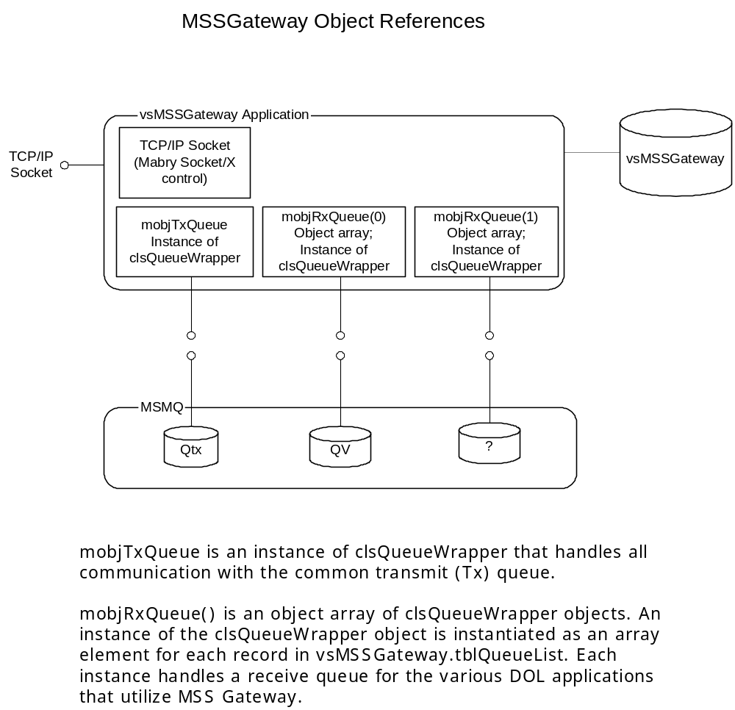

Appendix B: Platform and system requirements for vsMSSGateway

Development: Visual Basic 6.0 SP5 on a Windows 2000 SP2 Professional platform, ADO 2.6.

System Components: MSMQ Service
SOCKETX.OCX
SOCKETX.DLL
VSQUEUEWRAPPER.DLL
MQOA.DLL
NTSVC.OCX

Additional Reference Material:
Detailed technical information regarding the functional operation and installation of vsMSSGateway:
G:\SYSTEMS\VB6_Applications\vsMSSGateway\Doc\Install.doc
G:\SYSTEMS\VB6_Applications\vsMSSGateway\Heat20677\doc\Install_MSSGatewayDB.doc

Detailed information regarding the vsQueueWrapper.DLL:
G:\SYSTEM\VB6_Applications\ActiveX Components\vsQueueWrapper\Doc\clsQueueWrapper.doc

Detailed information regarding using VB to create an NT Service:
G:\SYSTEMS\VB6_Applications\vsMSSGateway\Doc\Using VB to Create an NT Service.doc

MSMQ COM Reference:
http://msdn.microsoft.com/library/default.asp?url=/library/en-us/msmq/msmq_ref_app_81gz.asp?frame=true

Mabry Socket/X Reference:
http://www.mabry.com/socketx

Appendix C: Diagrams
